# Mehdi Abbas - 461734

# Day 5: Testing, Error Handling, and Backend Integration Refinement

## Objective

Day 5 focuses on ensuring that the furniture marketplace is deployment-ready by thoroughly testing its functionalities, optimizing its performance, and documenting results. Key areas include:

1. Conducting comprehensive testing of core functionalities.
2. Implementing robust error handling mechanisms.
3. Optimizing for performance, accessibility, and SEO.
4. Ensuring cross-browser and cross-device compatibility.
5. Documenting findings and fixes in a professional format.

## Key Learning Outcomes

1. Validate all functionalities through functional and user acceptance testing.
2. Improve website performance metrics using tools like Lighthouse.
3. Ensure high accessibility scores for users with disabilities.
4. Enhance SEO for better search engine visibility.
5. Prepare detailed documentation and a CSV-based testing report.

## Implementation Steps

### Step 1: Functional Testing

**Description:** Validate the functionality of key components to ensure they work as expected.

**Features Tested:**

* Navigation links: Ensure all links navigate correctly.
* Product listing and details: Verify accurate rendering of products.
* Shopping cart operations: Validate add, update, and remove functionalities.
* Blog accessibility: Ensure blog content is accessible.
* Contact form: Confirm successful form submissions.

### Step 2: Error Handling

**Description:** Implement mechanisms to gracefully handle errors and provide user-friendly feedback.

**Approach:**

* Utilize try-catch blocks to handle API errors.
* Display fallback UI elements, such as "No products available" when data is unavailable.
* Log errors for debugging purposes.
* Ensure graceful handling of failed API responses to maintain user trust and interface consistency.

### Step 3: Performance Optimization

**Description:** Identify and resolve performance bottlenecks using tools like Google Lighthouse.

**Performance Metrics:**

* Performance: 77
* Accessibility: 91
* Best Practices: 96
* SEO: 100

**Key Improvements:**

1. Reduce initial server response time.
2. Minimize unused JavaScript (savings of 25 KiB).
3. Implement lazy loading for large images.

### Step 4: Cross-Browser and Device Testing

**Description:** Ensure consistent functionality and rendering across browsers and devices.

**Browsers Tested:**

* Chrome, Firefox, Safari, Edge.

**Focus Areas:**

* Responsive design.
* Consistent navigation and interactivity.
* Verified accessibility features, including keyboard navigation and screen reader compatibility.

### Step 5: Security Testing

**Description:** Secure the website against vulnerabilities.

**Key Actions:**

* Sanitize user inputs to prevent SQL injection and XSS attacks.
* Ensure API calls are made over HTTPS.
* Store sensitive information in environment variables.
* Conduct penetration testing to identify hidden vulnerabilities.

**Tools Used:**

* Manual testing for additional verification of potential vulnerabilities.

### Step 6: User Acceptance Testing (UAT)

**Description:** Simulate real-world user interactions to identify usability issues.

**Scenarios Tested:**

* Browsing products.
* Adding and removing items from the cart.
* Completing the checkout process.
* Testing multi-step workflows to ensure an intuitive user experience.

**Feedback Collected:**

* Minor UI inconsistencies identified and resolved.
* Improved workflows for better user experience.
* Adjusted visual hierarchy to emphasize key actions like "Add to Cart."

### Step 7: Self Test CSV Report

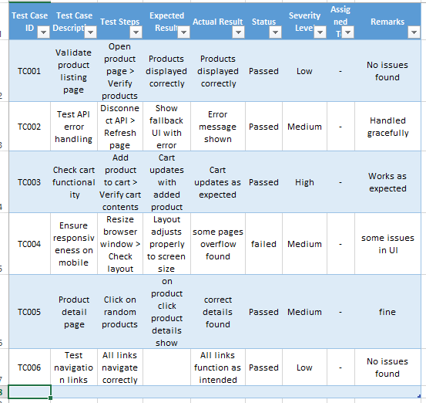

### Step 8: Documentation Updates

**Description:** Compile findings and resolutions into a professional report.

**Includes:**

* Test case descriptions and results.
* Performance optimization steps.
* Security measures implemented.
* Screenshots of issues and fixes.
* Additional insights into areas for future improvement.

## Conclusion

Day 5 successfully focused on enhancing the marketplace’s reliability, performance, and user experience. Comprehensive testing ensured all functionalities work as intended, while optimizations improved performance metrics and accessibility. Remaining SEO enhancements and performance tweaks will further refine the platform for deployment. This documentation and CSV report provide a clear roadmap of actions taken and next steps.